**Chapter 4**

**Feasibility Study**

**4.1 Introduction**

Many feasibility studies are disillusioning for both users and analysis. It tells us whether a project is worth the investment—in some cases, a project may not be doable. There can be many reasons for this, including requiring too many resources, which not only prevents those resources from performing other tasks but also may cost more than an organization would earn back by taking on a project that isn’t profitable. Each candidate’s system performance is evaluated against the system performance requirements set prior to the feasibility study. Whatever the criteria, there has to be as close a match as predictable, although tradeoffs are often necessary to select the best system.

In some cases, the performance and cost data for each candidate system show which system is the best choice. This outcome terminates the feasibility study.

4.2 Feasibility analysis**:**

In feasibility analysis, the solution of the problems that is feasible to solved are identified. In some problem we evaluate the proposed system with existing system by weighted candidate system evaluation matrix. We have selected some criteria based on the problem and give them weighting factor from 1 to 5. And we also given rating from 1 to 5 on different criteria of the proposed system and the exiting system. 5,4,3,2,1 refers for excellent, very good, fair, poor and very poor respectively. For some problem we also create DFD for proposed system.

**4.2.1 Logistics Allotments are delayed**

We have seen that logistics allotments are delayed in the different sub-branch of the Family Planning system. Since all the decisions are taken from the central office so there is some time taken for logistics allotments. So, if we decentralize the power then it requires less time. Decentralization refers to a specific form of organizational structure where the top management delegates decision-making responsibilities and daily operations to middle and lower subordinates. The top management can thus concentrate on making major decisions with greater time abundance. Decision-making becomes quicker and better at the same time, by pushing down the power to make a decision to the operational level, which is nearest to the situation.

**4.2.2 The entire system is not digitized**

The entire Family Planning system is not digitalized. Because today’s worlds are digital world. Technology is improving day by day. So, for giving quality service the system must be digitalized. If the entire system is digitalized then it can increase the efficiency of the system. There need adequate digital devices like computers, scanners, printer, Fax, etc. And also, there needs proper training for the employee to use these devices.

**4.2.3 Fast Paced training is not effective**

To increase the efficiency of the employee and also for adapting to new technology training must be a crucial part of a system. The exiting system of Family Planning has been arranged training for the employee but it is not enough for the employee since it is short termed i.e. 1-3 days. In our proposed system we suggest changes the structure of the training and also increases the time length of the training.

**4.2.4 E-nothi System is not being implied properly**

The Bangladesh government has been declared that everything i.e., every offline file must also have softcopy version that is E-Nothi. E-Nothi (e-filing) is one of the flagship programmes of the Digital Bangladesh initiative, and serves as a single online platform for conducting official file management. But E-Nothi is not completely applied on the whole system. There are several problems with appling E-Nothi system such as the Family Planning system has many senior employees whose are not familiar with the use of computer although there are some employees whose have some basic knowledge about computer but they are not comfortable with it. To solve those problem training about computer technology required and also the training should be descriptive and detail. But only training is not enough to applied the E-Nothi system. There must be proper monitoring from the higher officers and also authority must strict about applied E-Nothi system.

**4.2.5 There is no personal datasheet or database**

The Family Planning System has no database. From a database the official staffs may find useful information such as promotion, salary, bonus and also it is useful for those who want to apply application on a vacant post. So, in keeping those advantage in mind it is feasible to build a database for Family Planning system. At chapter 5, we have been showed the database structure for Family Planning system.

**4.2.6 Not enough positions or promotions in the structure**

In Family Planning system there are few numbers of positions in the existing system. For this reason, there are not adequate promotion for the employee the system. As the employee are not promoted to higher level their efficiency of work is reduced. Our Proposed system we create a DFD (Data Flow Diagram) for the promotion of the employee. The DFD are shown below.

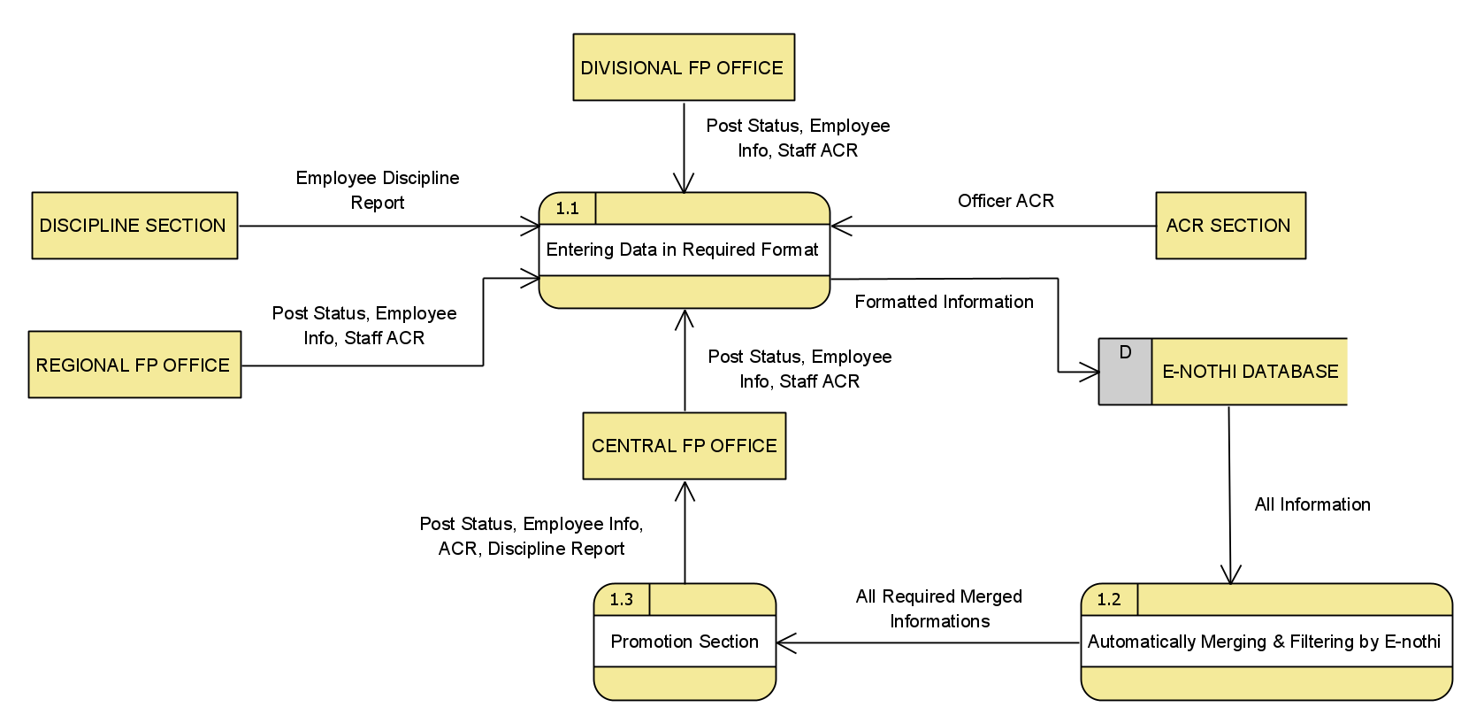

Fig. 4.1: The Data flow diagram for promotion level in the proposed system

**4.2.7 Not proper monitoring system during the recruitment**

In new recruitment, there are some problems in the existing system. Such as the recruitment system is not digitalized and also there is no proper monitoring during the recruitment so proper manpower cannot be hired. In our proposed system, we create a database for digitalized recruitment and also, we create a DFD for the recruitment system. At chapter 5, the database for recruitment system is shown.

Table 4.1 weighted candidate system evaluation matrix for increasing numbers of manpower versus a RMAT (Recruitment management and applicant tracking) system.

|  |  |  |  |  |  |
| --- | --- | --- | --- | --- | --- |
| **Evaluation Criteria** | **Weighting factor** | **By increasing manpower in the existing system** | | **By creating recruitment management system** | |
| **Rating** | **Score** | **Rating** | **Score** |
| **Performance**  Merit justification  Integration  Hiring process  Tracking  User interface  Processing Speed  Security  **Cost**  Salary  Training  Maintainance | 2  4  3  4  3  5  3  4  3  5 | 4  2  2  2  3  2  3  2  4  4 | 8  8  6  8  9  10  9  8  12  20 | 5  5  4  5  4  5  5  5  3  3 | 10  20  12  20  12  25  15  20  9  15 |
| Total score |  | 98 | | 158 | |

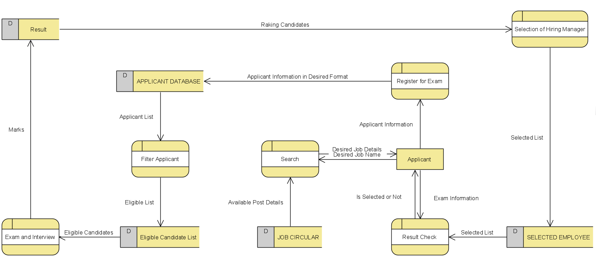

Fig. 4.2: Data flow diagram for (RMAT) Recruitment management and Applicant Tracking

**4.3 Conclusion**

In this chapter we have tried to give the feasible solution of the problems that are identified before and also give the reasons why these problems need to be solved. There are many considerations are taken into account to find out the feasible solutions of these problems.